EXCITING new ways to advertise and help NBA players!

Advertising Banners at Newmarket’s Premium Diamonds

Sponsors are able to purchase premium ad space on the outfield fences at any of three of the premium baseball diamonds in Newmarket. The diamonds include: McKnight: Whipper Watson: and Armstrong Diamond. You will have a chance to work with professional designers to create the perfect eye-catching sign for your company.

We had nearly 1000 players registered in 2024. Our players share the diamonds 6 days a week, from May until October! Meaning, for only $1,000 (the first year), you can easily reach thousands of people each season.

This is a great way to advertise your company and to support youth baseball in our community.
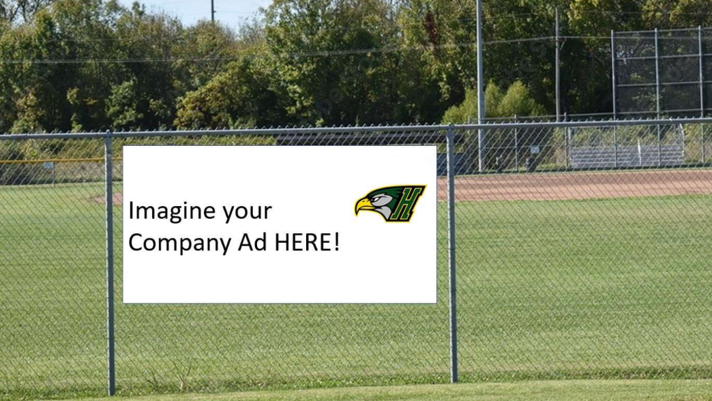
Each new sign is only $1,000 for the first season!

Your $1,000 outfield sign fee includes:
- One 4’x 8’; high quality; weatherproof; fade resistant; vinyl sign; in FULL COLOR
- Set up and design
- Choice of location - McKnight, Whipper Watson, Armstrong
- Displayed from May to mid-October
- Discounted fee for multi-year or renewed ads

To get in on this amazing opportunity please complete the attached form below and email to admin@newmarketbaseball.com. You will be contacted within 1-2 days to discuss final details.

Thank you for your support of Newmarket Baseball Association!

2025 Outfield Sign Application
Please forward completed application to admin@newmarketbaseball.com

Company Name: _____________________________________________________

Company Phone: ____________________________________________________

Company Email: _____________________________________________________

Company Website: ___________________________________________________

Contact Name: ______________________________________________________

Number of Signs: One Two Three

Preferred Diamond: McKnight Whipper Watson Armstrong

Signature: ____________________________ Date: _________________________

Payment Method: Cheque Etransfer

Please make cheque payable to: Newmarket Baseball Association – Attention “Outfield Sign”
Mail to: P.O. Box #3, Newmarket, Ontario, L3Y 4W3.
OR E-Transfers can be sent to admin@newmarketbaseball.com
Sponsorship Payments are Due February 1, 2025!
Please forward artwork/logos to admin@newmarketbaseball.com

